

**SK KHAJA MAINUDDIN**

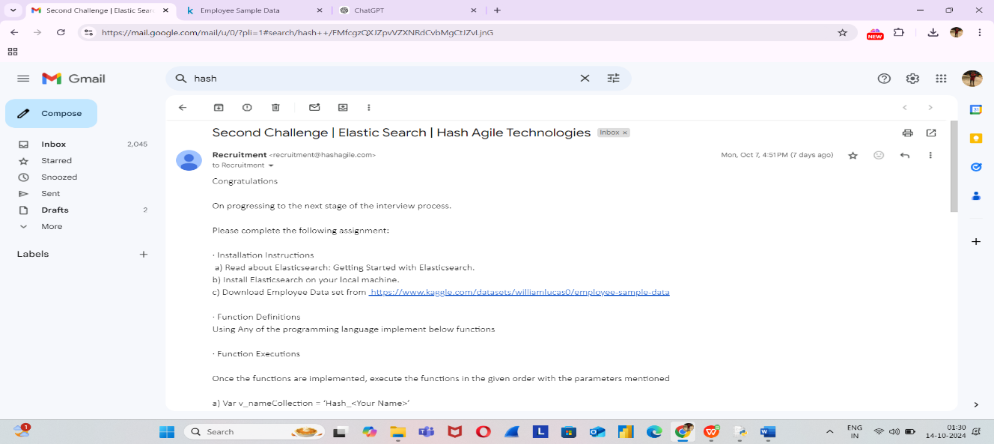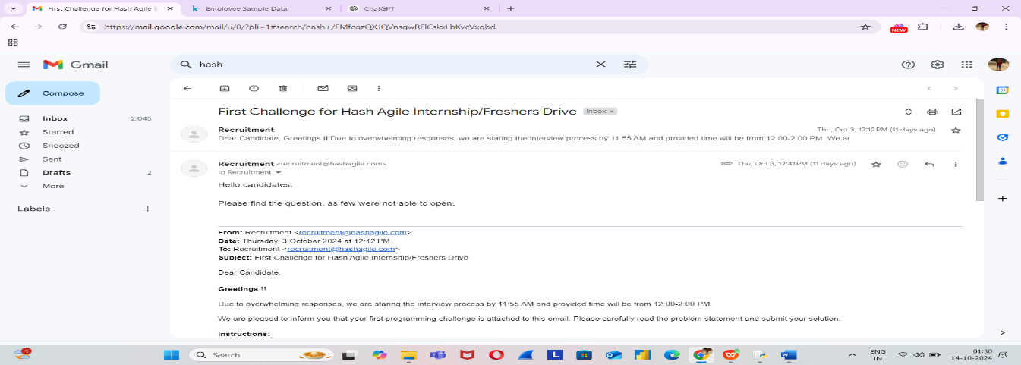

Github Link for Round1: <https://github.com/CISNKPJUKFJV/Round-1.git> Github Link for Round2: https://github.com/CISNKPJUKFJV/Round-2.git

Code:

import pandas as pd

employee_df = pd.read_csv(r"C:\Users\mainu\Downloads\archive (7)\Employee Sample Data 1.csv", encoding='ISO-8859-1')

collections = {}

def createCollection(name):

collections[name] = employee_df.copy()

def getEmpCount(collection_name):

return len(collections[collection_name])

def indexData(collection_name, column_name):

if column_name in collections[collection_name].columns:

collections[collection_name].set_index(column_name, inplace=True)

else:

print(f"Column '{column_name}' not found in collection '{collection_name}'.")

def delEmpById(collection_name, emp_id):

collections[collection_name].drop(collections[collection_name][collections[collection_name]['Employee ID'] == emp_id].index, inplace=True)

def searchByColumn(collection_name, column_name, value):

if column_name in collections[collection_name].columns:

return collections[collection_name][collections[collection_name][column_name] == value]

else:

print(f"Column '{column_name}' not found in collection '{collection_name}'.")

return pd.DataFrame()

def getDepFacet(collection_name):

if 'Department' in collections[collection_name].columns:

return collections[collection_name]['Department'].value_counts()

else:

print(f"Column 'Department' not found in collection '{collection_name}'.")

return pd.Series()

v_nameCollection = 'Hash_JohnDoe'

v_phoneCollection = 'Hash_1234'

createCollection(v_nameCollection)

createCollection(v_phoneCollection)

print("Employee count in v_nameCollection:", getEmpCount(v_nameCollection))

indexData(v_nameCollection, 'Department')

indexData(v_phoneCollection, 'Gender')

print("Employee count after indexing:", getEmpCount(v_nameCollection))

delEmpById(v_nameCollection, 'E02003')

print("Employee count after deletion:", getEmpCount(v_nameCollection))

print("Search by Department (IT) in v_nameCollection:\n", searchByColumn(v_nameCollection, 'Department', 'IT'))

print("Search by Gender (Male) in v_nameCollection:\n", searchByColumn(v_nameCollection, 'Gender', 'Male'))

print("Search by Department (IT) in v_phoneCollection:\n", searchByColumn(v_phoneCollection, 'Department', 'IT'))

print("Department facet in v_nameCollection:\n", getDepFacet(v_nameCollection))

print("Department facet in v_phoneCollection:\n", getDepFacet(v_phoneCollection))

**Output**

